Semantic Source Code Analysis: A Comparative Example with Fibonacci Sequence

The Code Example: Fibonacci Sequence
Consider the following Python function for calculating the nth Fibonacci number:
Python

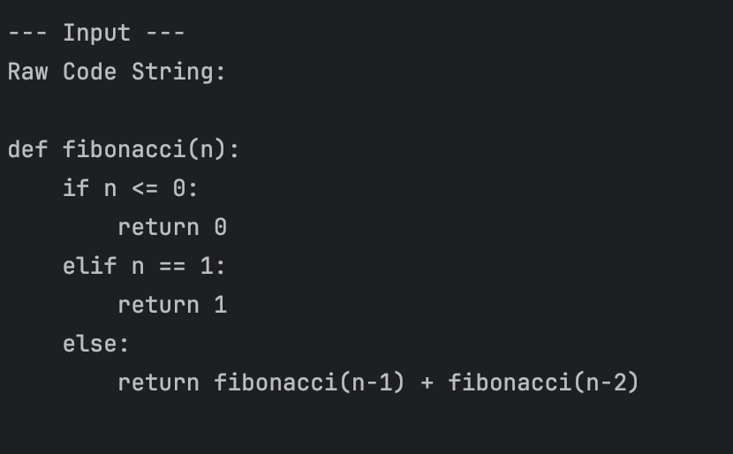
This recursive function, while simple in appearance, presents several semantic challenges:
•Syntactic: Function definition, conditional statements (if, elif, else), recursive calls, arithmetic operations.
•Semantic: The mathematical concept of the Fibonacci sequence, the base cases, and the recursive relationship between terms.
•Pragmatic: The function's purpose (mathematical utility), its efficiency implications (exponential time complexity for naive recursion), and its common use as a programming example.

Baseline Transformer Analysis
A traditional baseline transformer model processes code as a flat sequence of tokens. While it can learn statistical relationships between these tokens, it lacks an inherent understanding of the code's hierarchical structure or the specific semantic roles of different code elements. Its analysis would proceed as follows:
1.Tokenization: The code is broken down into individual tokens (e.g., def, fibonacci, (, n, ), :, if, n, <=, 0, etc.).
2.Positional Encoding: Each token's position in the sequence is encoded.
3.Self-Attention: The model computes attention scores between all pairs of tokens. For instance, fibonacci might attend to n-1 and n-2, but without explicit structural guidance, it might also attend equally to unrelated tokens like return in a different branch.
4.Feed-Forward Networks: Token representations are transformed through feed-forward layers.
5.Output: The model produces a classification based on the aggregated token representations. For our example, it might classify the function as Function_Definition or Recursive_Function, but its understanding of the mathematical concept or the recursive calls' specific roles would be limited.
Limitations of Baseline: The baseline transformer's flat-sequence processing and generic attention can struggle with:
•Syntactic Hierarchy: It doesn't inherently understand that if n <= 0: is a conditional statement governing a specific return or that fibonacci(n-1) and fibonacci(n-2) are recursive calls within the else branch.
•Semantic Context: While it sees fibonacci repeated, it may not deeply grasp the recursive nature or the mathematical relationship without explicit structural guidance.
•Pragmatic Intent: Inferring the higher-level purpose of the function (e.g., its use in mathematical computations) or its efficiency characteristics is challenging without explicit structural guidance.

CodeLACE Analysis: A Step-by-Step Approach
CodeLACE, with its Adaptive Sparse Attention, Hierarchical Token Pooling, and Code-Specific Mixture of Experts, processes the fibonacci function with a deeper understanding of its structure and semantics. Here's how CodeLACE would analyze the same example:

1.Code-Aware Tokenization: Similar to the baseline, but with an initial pass that identifies syntactic boundaries (e.g., function boundaries, conditional blocks, statement ends).
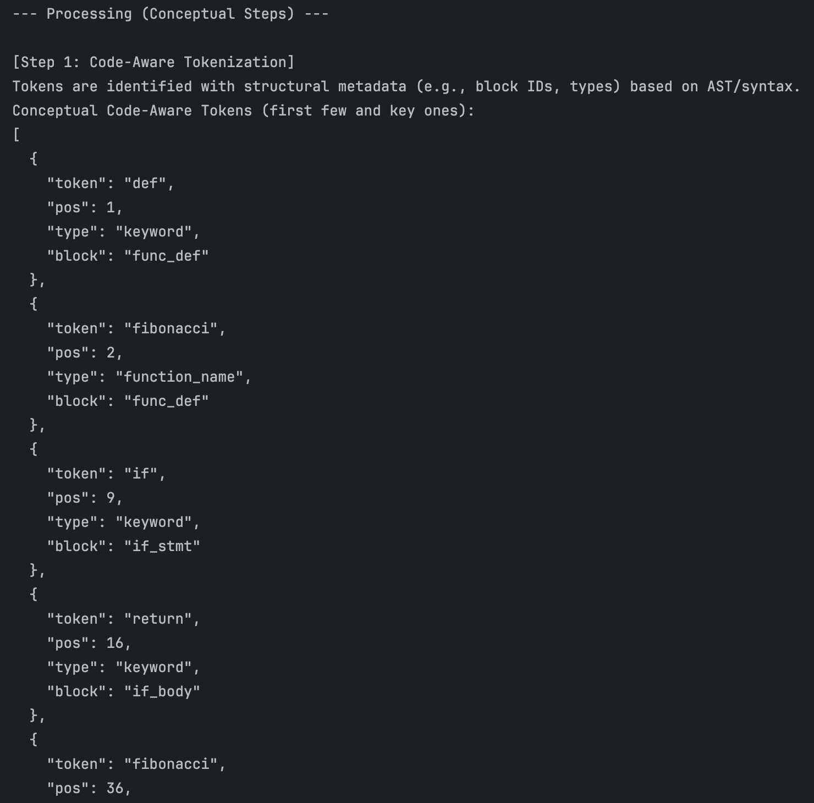

2.Adaptive Sparse Attention: Instead of attending to all tokens equally, CodeLACE's attention mechanism dynamically focuses on syntactically and semantically relevant tokens. For fibonacci(n-1), it would prioritize the function definition def fibonacci(n): and the other recursive call fibonacci(n-2), as these are directly related to its execution flow and semantic meaning. It would largely ignore comments or unrelated code blocks.
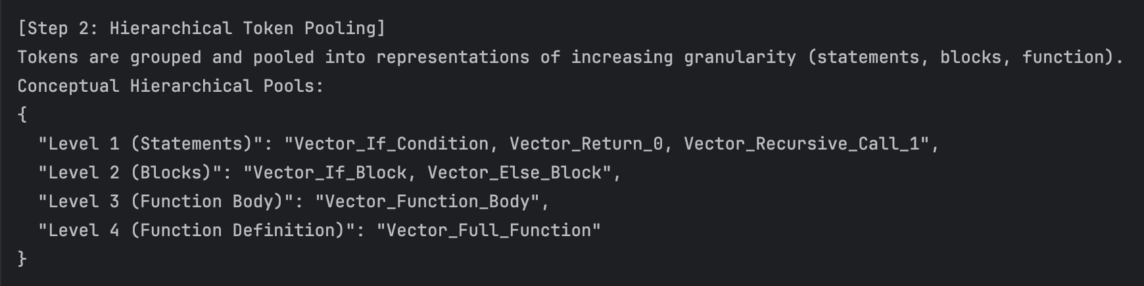
3.Hierarchical Token Pooling: This is where CodeLACE significantly diverges. It would:
•Level 1 (Token to Statement/Expression): Pool tokens within n <= 0, return 0, n == 1, return 1, and fibonacci(n-1) + fibonacci(n-2) to form representations of these individual expressions and statements.
•Level 2 (Statement/Expression to Block): Pool the representations of statements within the if, elif, and else blocks to form representations of these conditional branches.
•Level 3 (Block to Function Body): Pool the representations of the conditional blocks to form a representation of the entire function body.
•Level 4 (Function Body to Function Definition): Combine the function body representation with the function signature (def fibonacci(n):) to form a complete function representation. This hierarchical pooling preserves the structural context, allowing CodeLACE to understand the nested nature of the conditionals and the recursive calls within the else branch.
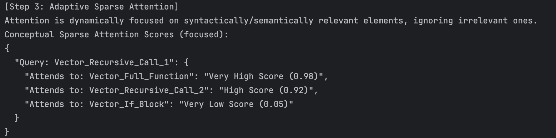
4.Code-Specific Mixture of Experts (MoE): As the representations pass through CodeLACE's layers, the gating network routes them to specialized experts. For this Python example, an expert trained on Pythonic idioms, recursion patterns, and mathematical functions would be activated. This expert is highly optimized to understand the nuances of Python syntax and the semantics of recursive computations within code.
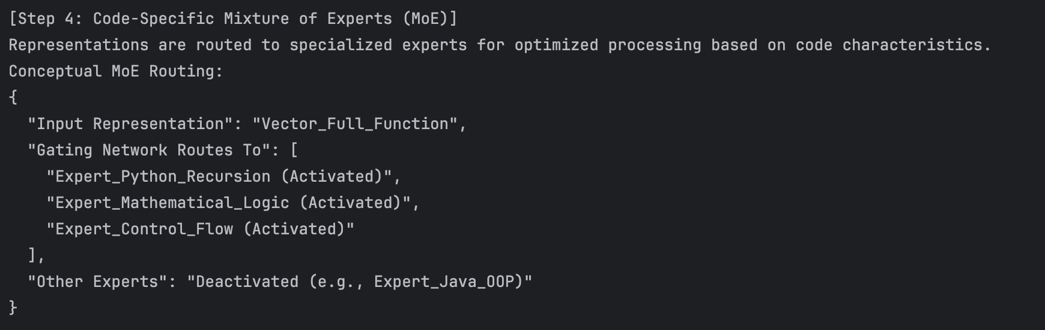
5.Output: CodeLACE produces a multi-level classification:
•Syntactic: Function_Definition, Conditional_Statement, Recursive_Call, Arithmetic_Operation.
•Semantic: Fibonacci_Calculation, Mathematical_Sequence, Recursive_Algorithm.
•Pragmatic: Mathematical_Utility, Illustrative_Example_of_Recursion.

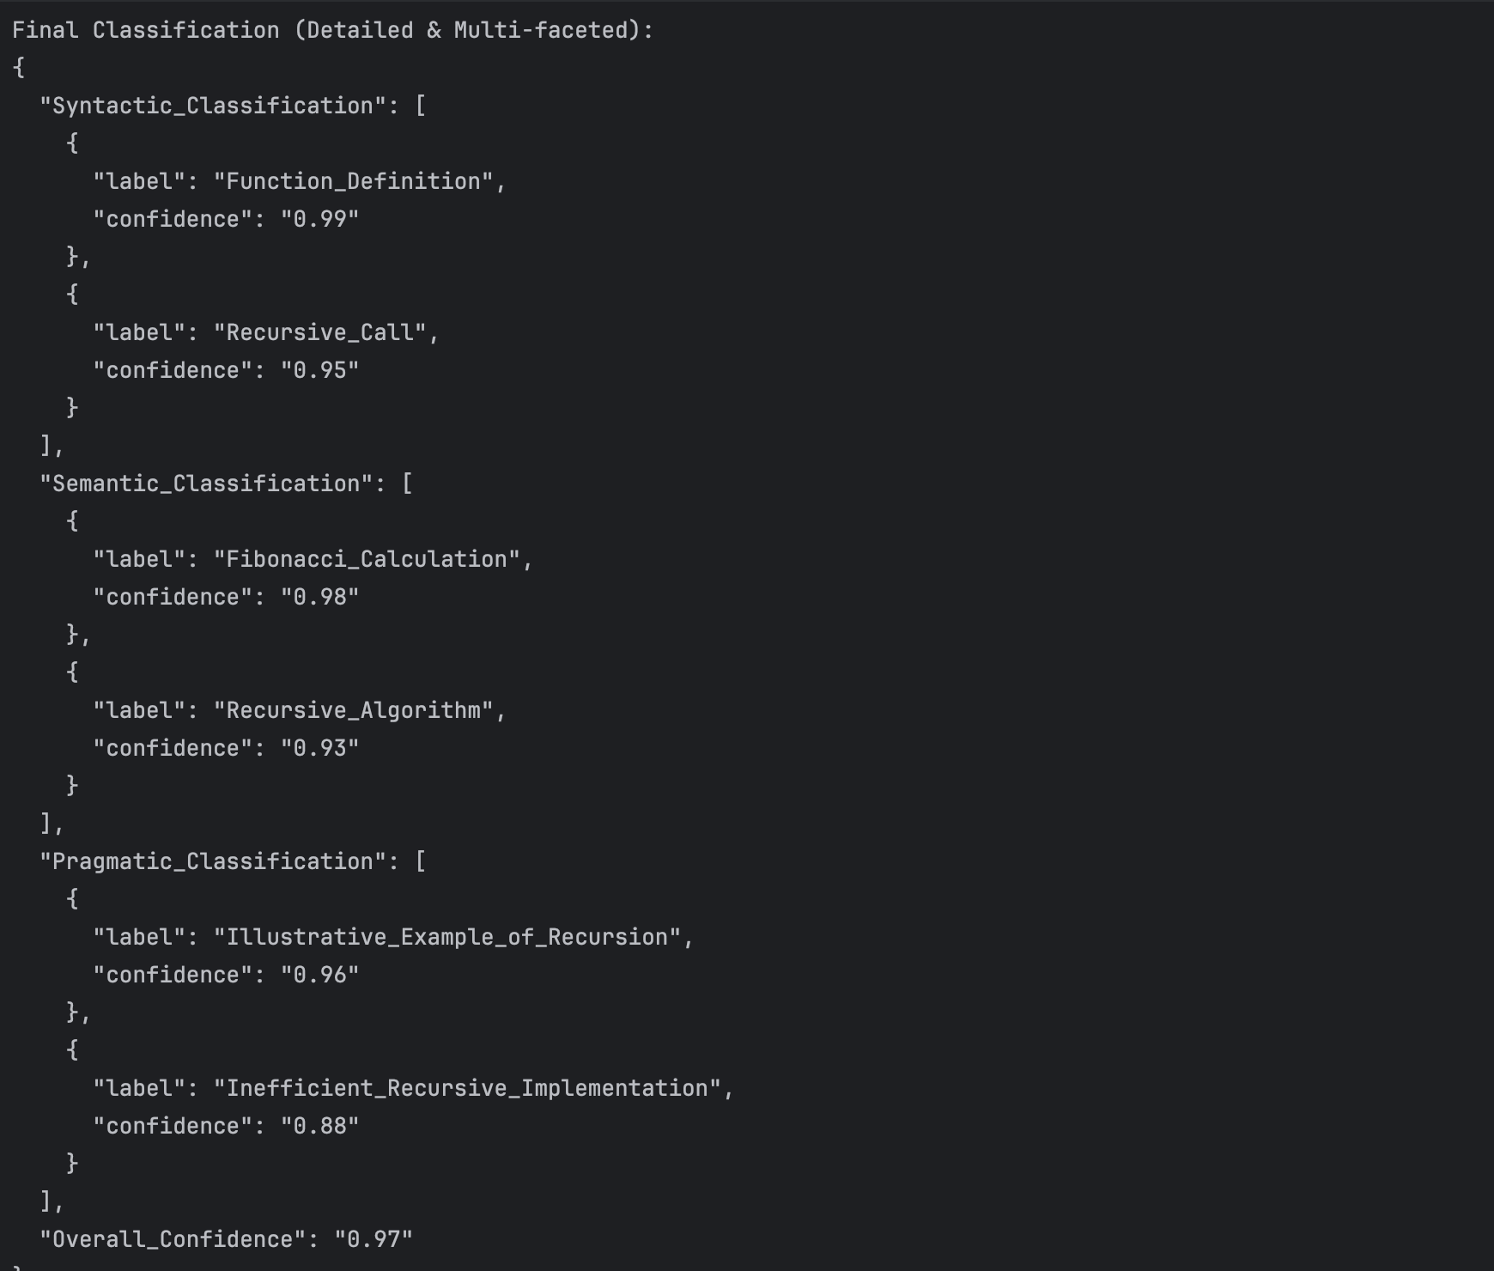

Visualizing the Difference

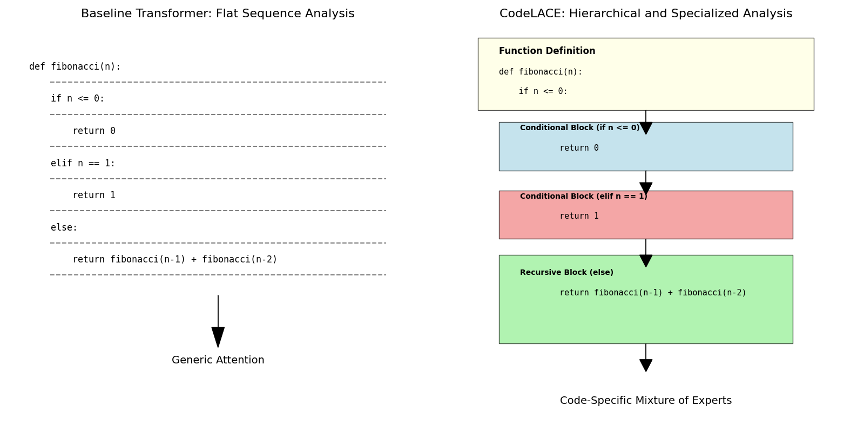

Conclusion
This example demonstrates CodeLACE's superior capability in semantic source code analysis. By integrating adaptive sparse attention, hierarchical token pooling, and a code-specific mixture of experts, CodeLACE moves beyond treating code as mere text. It understands the inherent structure, meaning, and intent, providing a more accurate and fine-grained analysis crucial for advanced software engineering tasks. This detailed understanding allows CodeLACE to achieve significantly higher accuracy and F1-scores compared to traditional baseline models, making it a more effective tool for real-world code comprehension and classification.

